Design for Problem 2 Day 6 (HW)
- Ask the user to provide a word and print the amount of vowels in the word.
- Examples
  - User input “Hello” ll print “There are 2 vowels in the word Hello”
- Pseudocode
Define main function:
Vowels = “aeiouy”
vowelNum = 0
word = word inserted
for each letter in word
If the letter is in the vowels
Add 1 to vowelNum
print the amount of vowels in the word
call main function to execute program

- Variable(s)
  - vowels
  - vowelNum
  - word
  - letter

- Python Statements
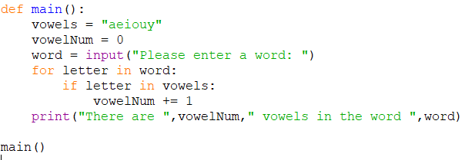
- Inputs and Outputs
  - Input – word(string)
  - Output – vowelNum(int), word(string)
- Python Code (turned in as .py file)

